

**INTRODUCTION:**

New York-based Global Superstore is an international online retailer with a wide selection of products that strives to serve as a one-stop shop for its clients. Worldwide Customers of the emporium, who come from 147 different countries, can peruse an extensive selection of over 10,000 products. Three primary areas make up this enormous assortment: technology (such as cellphones), furniture (such as chairs), and office supplies (such as staples).

**PROBLEM STATEMENT:**

**Question 1.**

* What are the three countries that generated the highest total profit for Global Superstore in 2014?
* For each of these three countries, find the three products with the highest total profit. Specifically, what are the products names and the total profit for each product?

**Question 2.**

* Identify the 3 subcategories with the highest average shipping cost in the United States.

**Question 3.**

* Assess Nigeria’s profitability (i.e., total profit) for 2014. How does it compare to other African countries?
* What factors might be responsible for Nigeria’s poor performance?

**Question 4.**

* Identify the product subcategory that is the least profitable in Southeast Asia.
* Is there a specific country in Southeast Asia where Global Superstore should stop offering the subcategory identified in the above.

**Question 5**

* Which city is the least profitable in the United States
* Why is this city’s average profit so low

**Question 6**

* Which product subcategory has the highest average profit in Australia?

**Question 7**

* Who are the most valuable customer and what do they purchased?

**SKILLS DEMONSTRATED:**

* Power Query
* Data Modeling
* Data Cleaning
* Data Visualization
* Filters

**DATA SOURCING:**

For my project as a scholarship student, Digitaley Drive offered this dataset

<https://docs.google.com/spreadsheets/d/1nxESpFzWjlGDMGDVLH69xmDzIl9l6OEq/edit#gid=633280281>

**DATA TRANSFORMATION:**

The data was thoroughly cleaned and transformed with Power BI's Power Query Editor. Important actions in this procedure were:

**Data Cleansing:**

* Taking out extra spaces.
* Taking care of and managing empty cells.
* Duplicate entries are removed.
* Duplicate entries are removed.
* transformation of numbers based on language into numerical values.

**DATA MODELING:**

I examined relationships closely as I moved on to data modeling after finishing the data conversion stage. After using Power Query to clean up the data, I exported it into Power BI, where relationships were created effortlessly. But I carried out a thorough examination to make sure there were no mistakes and to confirm the accuracy of the linkages between various data sets.

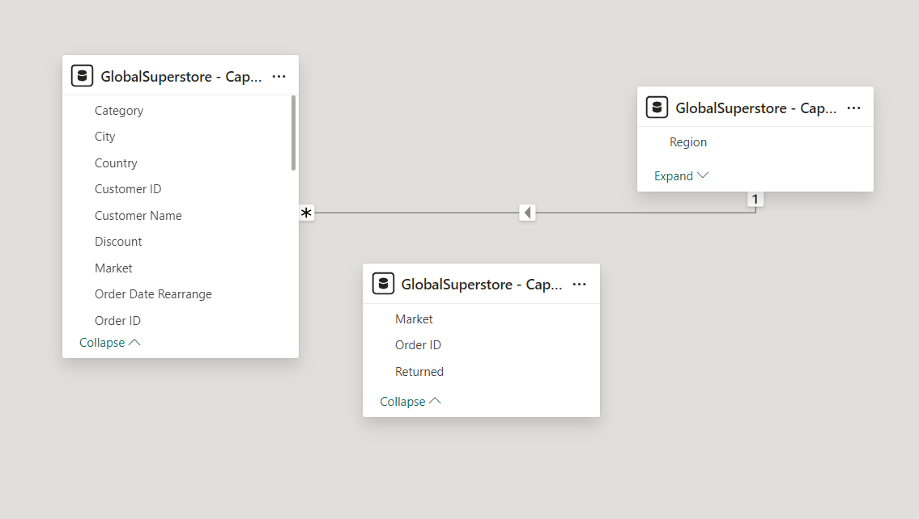

**ANALYSIS AND VISUALIZATION**

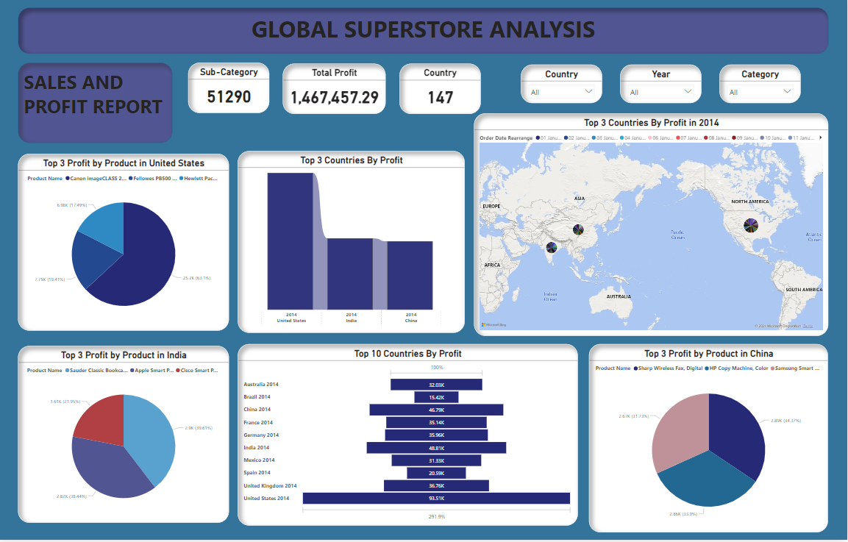

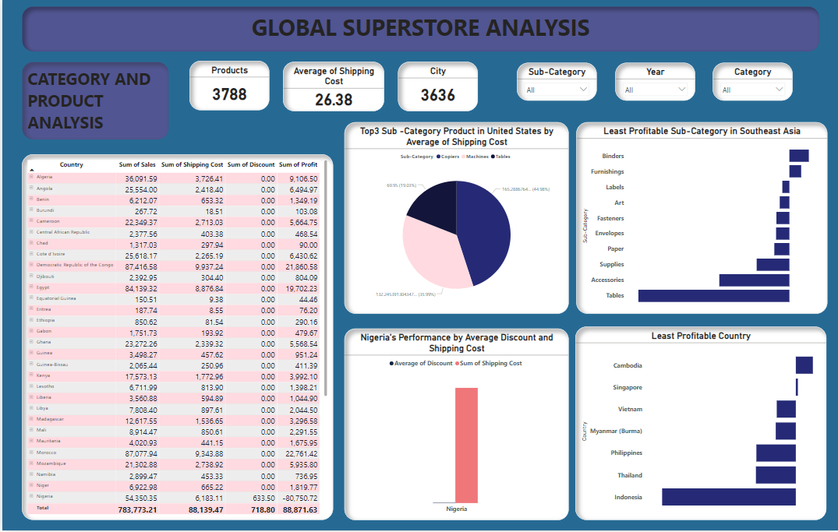

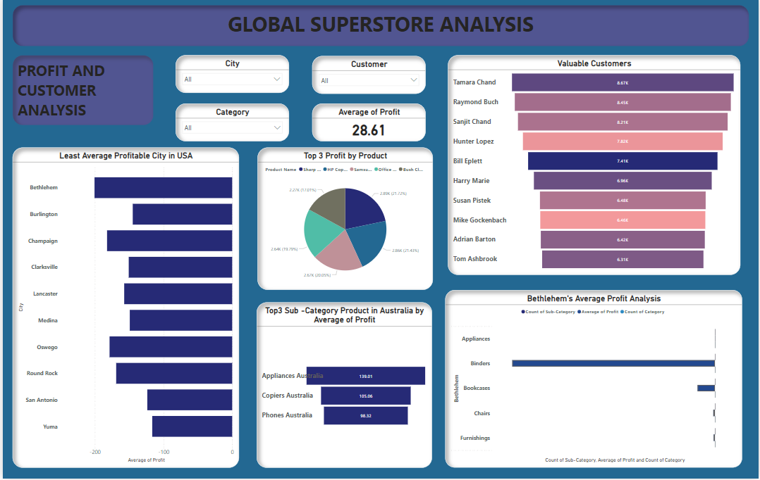

* The business generated a substantial number of sales, reaching an outstanding $12.64 million in total sales.
* The previously 25.04K unique order count demonstrates a wide range of consumer interaction and reliable order placement over the specified time frame.
* The logistics and fulfillment costs were highlighted by the $1.35 million shipping operations' charges.
* The company demonstrates skillful cost control and operational effectiveness, generating a $1.47 million profit.
* The significant purchase amount of 178K products indicates a high level of interest and a notable volume of transactions.
* The 1,173 units that were returned show that a sizable number of products are being returned, suggesting a possible chance to improve client happiness or the durability of the product.
* Three separate categories indicate a systematized approach to product sorting, which may facilitate efficient inventory control and focused marketing campaigns.
* By adding 17 subcategories, the product variety is further refined, allowing for more focused marketing tactics and a wider market reach.

In 2014, the store generated profits of $504.16K from customers in 138 countries. The primary contributors to this total profit were the USA, contributing $93K, followed by India at $49K, and China with $47K. Together, these top three countries constituted almost 37.5% of the store's overall profits for the year. 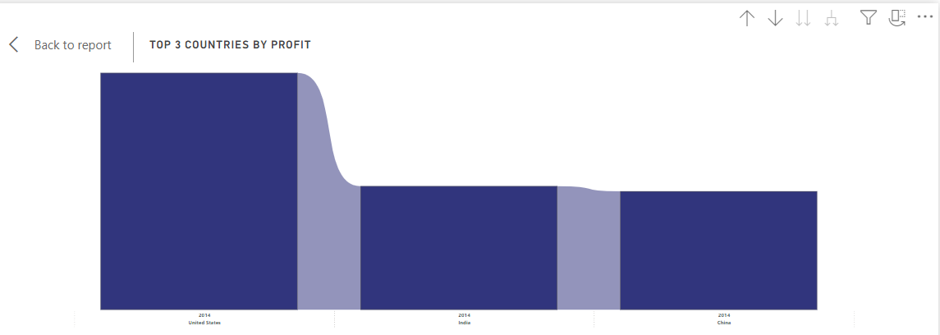

In 2014, the United States industry had three notable goods that generated considerably to overall profit:

* In the year 2014, the shop produced $504K from clients in 147 countries. The United States contributed the most to the overall earnings ($93K), next to India ($48K) and China ($46K). Collectively, the highest countries accounted for over 37.5% of the store's total revenues for the year.
* The Canon imageCLASS 2200 Advanced Copier had the highest profit of $25.19K, accounting for 63.1% of the total profit.
* The Fellowers PB500 Electric Punch Plastic Comb Binding Machine ranked secondly with earnings of $7.7K, accounting for 19.41% of total profit.

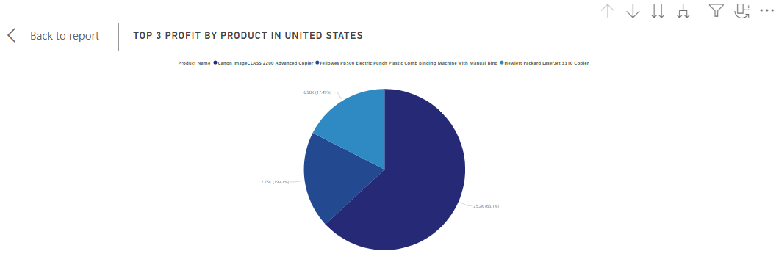

In India for the year 2014, the top three profit-generating products were as follows:

* The Sauder Classic Bookcase, Traditional had the highest profit of $2.90K, accounting for around 5% of the whole profit.
* The Apple Smart Phone with Caller ID ranked second with a profit of $1.44K, accounting for about 2.95% of the overall profit.
* The Cisco Smart Phone with Caller ID earned $1.61K, accounting for about 3.30% of the overall earning



According to typical delivery prices, the top three subcategories in the US are as follows:

* With an average delivery cost of $165.29, copies come in first place.
* In second place, machines are not far behind, with an average shipping cost of $132.25.
* Tables, with an average shipping cost of $69.95, take third place on the list.

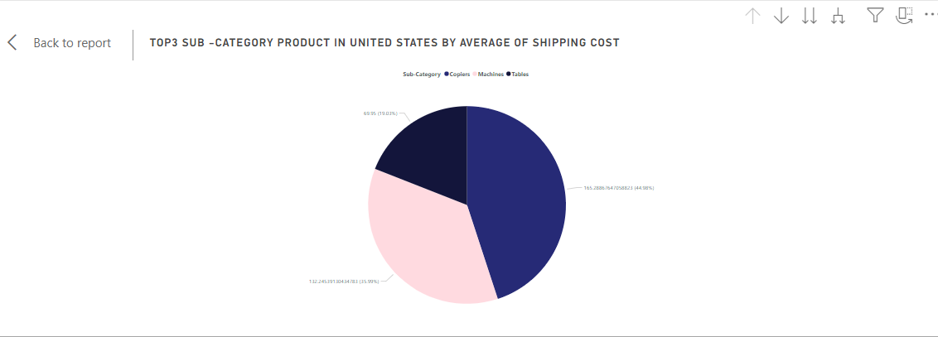

The total profit made by African nations in the year was $39.33K. Nigeria, which ranks 39th out of the 39 African countries, had the lowest profit, coming in at -$23.28K.

On the other hand, South Africa came in first place with the largest profit, $9.36K, followed by Morocco ($8.44K) and Egypt ($6.49K). The profit in South Africa amounts to about 23.8% of the entire profit in Africa. Morocco's share of the profit is approximately 21%. profit.



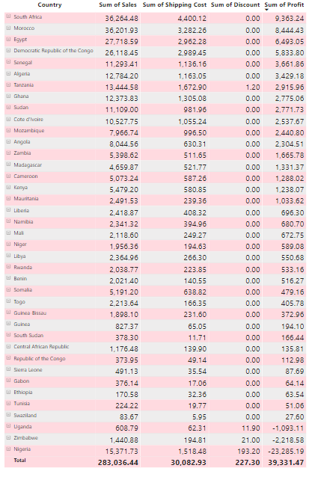

With an aggregate profitability of $17.85K, Southeast Asia accounts for 1.21% of the store's total gain in all areas. Tables was the least lucrative of the 17 different subcategories in the region, with a reported loss of -$18.61K. In close succession, Accessories lost -$8.64K, while Supplies had a -$4.03K loss. In Southeast Asia, the loss resulting from Tables amounts to roughly -104.5% of the whole profit. The margin of profitability for accessories is negative 48.4% of the total. A negative 22.5% of the region's total earnings is attributable to supplies.

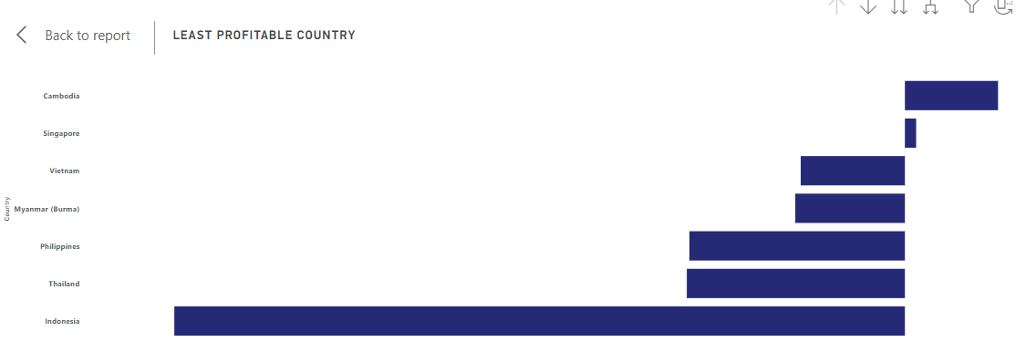

Tables' revenue growth in seven different nations in Southeast Asia resulted in a collective loss of -$18.62K. With a loss of -$10.68K, Indonesia reported the lowest profit of all these countries. The loss for Indonesia is roughly -57.3%. Asia.

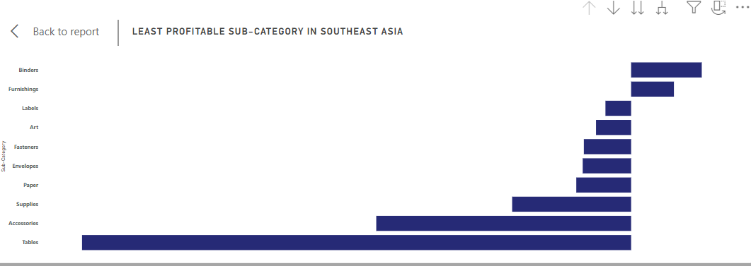

Achieving the highest average profit of $139.01 among 17 subcategories, Appliances stood out in Australia. In comparison with additional subcategories like copiers and phones, which posted earnings of $105.06 and $98.32, respectively, this highlights Appliances' noteworthy the superiority.

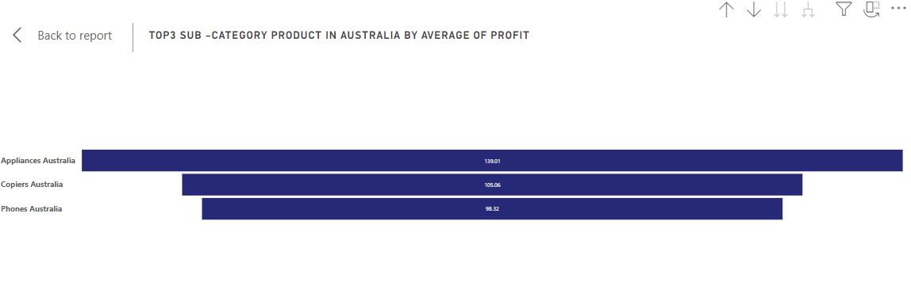

Over 1,590 consumers, the total earnings from all of them is $1.47 million. Based on sales volume and revenue margin, the most valuable clients among them are: Tamara Chand made a $8.67K contribution, or 0.6% of the total profit. Raymond Buch, who made $8.45K in profit (0.58% of total earnings). Sanjit Chand, producing $8.21K, or 0.55% of the entire profit). Hunter Lopez who made $7.82K in profit (0.53% of total earnings). And lastly on our top fifth valuable customer is Bill Eplett, producing $7.41K in profit with 0.53% total profit

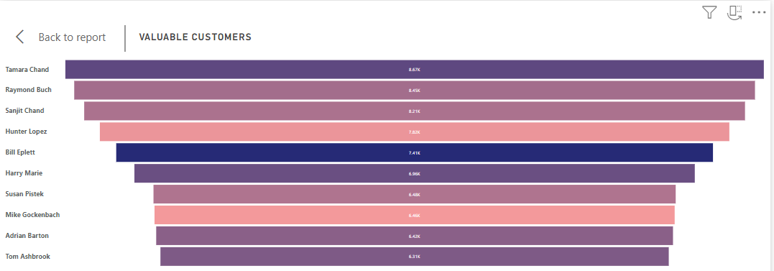

Thank you for taking the time to read this piece. Please share your thoughts. I am excited about them. Regards!